

Stock data Analysis using Hive.

Solution:

1. Create a directory in HDFS to copy this data in HDFS

You can create a directory in HDFS by executing below command and then copy give NYSE file into HDFS folder

hdfs dfs -mkdir /NYSE_daily

hdfs dfs -put NYSE_daily_File /NYSE_daily

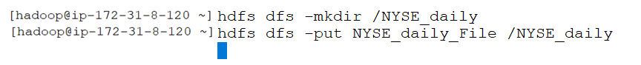

2. To Load data into partitioned table, we need to load data into non-partition table and then by using SQL Query we can load the data into partitioned table.

Lets create "NYSE" as non partition table

hive>

create table NYSE(exchange_symbol string,company string,date_txn string,open_price float,day_high float,day_low float,close_price float,txn bigint,adjust_close float) row format delimited fields terminated by '\t' stored as textfile location 'hdfs:///NYSE_daily';



3.

Let’s create a partitioned table as ORC File which is partitioned on date field.

hive>

SET hive.exec.dynamic.partition=true;

SET hive.exec.dynamic.partition.mode=nonstrict;

create table NYSE_Partition(exchange_symbol string,company string,open_price float,day_high float,day_low float,close_price float,txn bigint,adjust_close float) partitioned by (date_txn String) stored as orcfile;

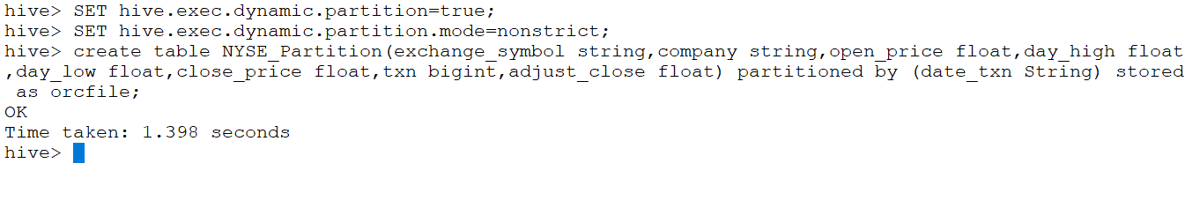

4.

Now, we can load data into partition table using Hive SQL Query

hive>

from NYSE insert into NYSE_Partition partition(date_txn) select exchange_symbol,company,open_price,day_high,day_low,close_price,txn,adjust_close,date_txn where open_price > 68 AND close_price <70;

